NAME: JEEVITHA.S-192324020
DATA BASE MANAGEMENT SYSTEM FOR WEB APPLICATION(CSA0555)
35-dynamic sql with dml statement
Create table:
CREATE TABLE employees_names (
employee_id NUMBER PRIMARY KEY,
first_name VARCHAR2(50),
last_name VARCHAR2(50),
hire_date DATE,
job_title VARCHAR2(100)
);
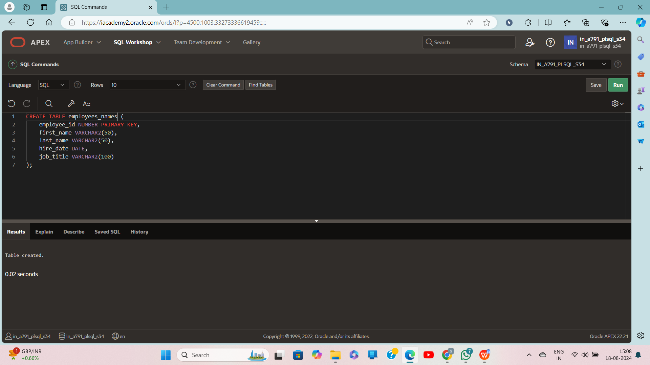
Create function:
CREATE FUNCTION del_rows(p_table_name VARCHAR2)
RETURN NUMBER IS
BEGIN
EXECUTE IMMEDIATE 'DELETE FROM ' || p_table_name;
RETURN SQL%ROWCOUNT;
END;
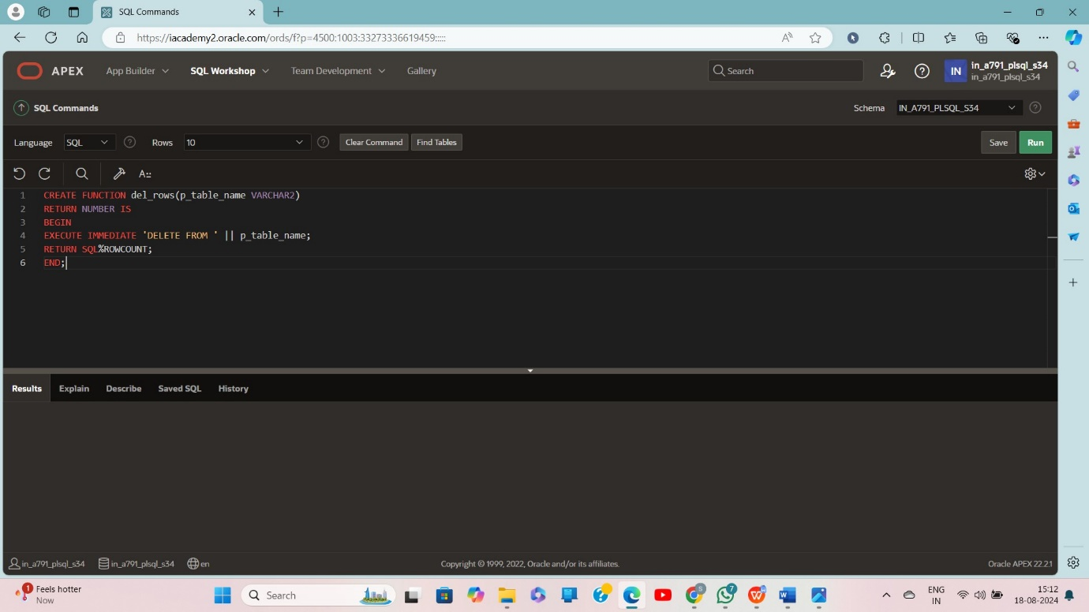

Declare:
DECLARE
v_count NUMBER;
BEGIN
v_count := del_rows('employees_names');
DBMS_OUTPUT.PUT_LINE(v_count || ' rows deleted.');
END;
